Algorithm 1. How to obtain proper factor to multiply or divide to calculate voltage value come from ADC.

For instance.

ADC input take voltage value from resistance divider like on below figure 1:

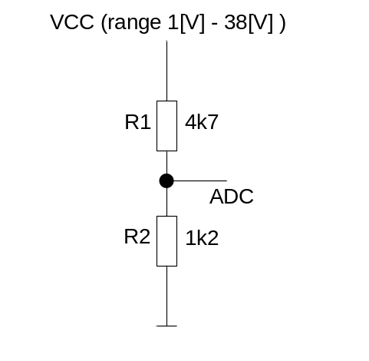
Figure 1: Simple resistor divider.

ADC input read voltage on R2 according to below equation:

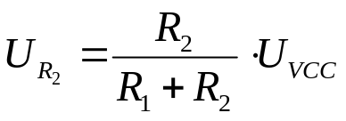

To correct estimate main power supply Vcc

ADC result shall be multiply by below factor:

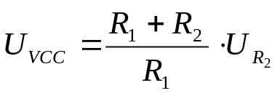

In current example factor will be equal 7,72881 ( R₁=4k7, R₂=1k2).

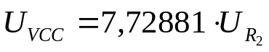

How to perform in real microcontroller.

The simples solution is use float type to describe factor but use of float variable in microcontroller compiler takes a lot of flash memory. Due to this problematic case below is simple solution for this.

unsigned int factor_base = 772881 (int type shall be 32bit variable).
unsigned int factor_div = 100000 (int type shall be 32bit variable).

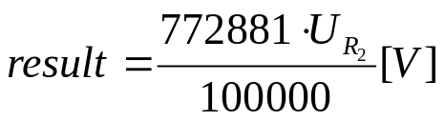

In Ansii C implementation

unsigned int factor_base = 772881;
unsigned int factor_div = 100000;

unsigned short adc_val = 0;

main(void)
{
unsigned int result = 0;

// Get value read from adc input channel “get_adc_value()”
// function is only assumption and shall be replaced
adc_val = get_adc_value();

result = factor_base * adc_val;

result /= factor_div;

// Result is ready in result variable and may be commit to other
// calculation or other purpose

while(1);

return(0);

}

To find proper divider value and factor_base and factor_div refer to excel document named “Algorithm_1_ADC_Calculations.xls”.

